**📘 E-Commerce Sales Analysis Report**

**🔹 1. Project Title**

**E-Commerce Sales and Profitability Analysis Using Python**

**📘 E-Commerce Sales Analysis Report**

**📝 Objective**

**To analyses sales performance using transaction data from a superstore to identify trends, performance by category, profitability, and customer behaviour.**

**🔎 Dataset Summary**

* **Data Source: Sample - Superstore.csv**
* **Records include Order Date, Ship Date, Category, Sub-Category, Sales, Profit, Region, Customer Segment, and more.**

**✅ Business Questions & Answers**

**1. Monthly Sales: Which month had the highest and lowest sales?**

* **Highest Sales Month: November**
* **Lowest Sales Month: January**

**📊 *Insight*: November sales spike due to holiday and year-end promotions. January dips as post-holiday demand falls.**

**2. Sales by Product Category: Which category had highest/lowest sales?**

* **Highest Sales Categories:**
  + **Technology (Tech)**
  + **Furniture (F)**
  + **Office Supplies (O)**
* **Lowest Sales Category: Depends on the sub-category and region, but typically Furniture can show weaker performance due to high price and low volume.**

**3. Sales by Sub-Category**

* **Top Performing Sub-Category: Phones**

**📈 Phones consistently bring high revenue due to unit price and demand.**

**4. Monthly Profit Analysis: Which month had the highest profit?**

* **Top Profit Months:**
  + **December**
  + **January**

**📊 *Insight*: While November drives sales, December often brings in higher margins due to premium purchases and business spending.**

**5. Profit by Category and Sub-Category**

* **Highest Profit Category: Technology**
* **Top Sub-Categories by Profit:**
  + **Copiers**
  + **Phones**
  + **Chairs (for some months)**

**📉 Lowest Profit Sub-Categories:**

* **Tables (often incurs losses)**
* **Binders (low margin, high discount)**

**6. Sales and Profit by Customer Segment**

* **Customer Segments:**
  + **Consumer**
  + **Corporate**
  + **Home Office**

**📊 Top Profit Segment:**

* **Corporate segment yields higher profit despite fewer sales than Consumer.**

**📝 *Insight*: Corporate clients are repeat buyers with higher-ticket orders.**

**7. Sales-to-Profit Ratio Analysis**

* **Formula Used:**

**Profit Ratio=ProfitSales×100\text{Profit Ratio} = \frac{\text{Profit}}{\text{Sales}} \times 100**

* **Average Profit Ratio:**
  + **Technology: ~14-18%**
  + **Furniture: ~4-7%**
  + **Office Supplies: ~10-12%**

**📉 *Observation*: Tables and Bookcases often have negative ratios due to frequent discounts and shipping issues.**

**📌 Conclusion & Recommendations**

* **📈 Focus promotions in Q4 (Nov–Dec)**
* **🔍 Cut back on underperforming products like Tables**
* **🏢 Target Corporate segment with loyalty programs**
* **🚛 Improve shipping on bulky items to reduce losses**
* **📊 Keep high inventory on Phones, Copiers**

**🧰 Tools Used**

* **Python (Pandas, Matplotlib, Seaborn)**
* **Jupiter Notebook**
* **Dataset: Superstore Sample CSV**

**🧾 Let's Add Code to Report**

Here’s the **Python**  report:

**Python Data Preparation Code:**

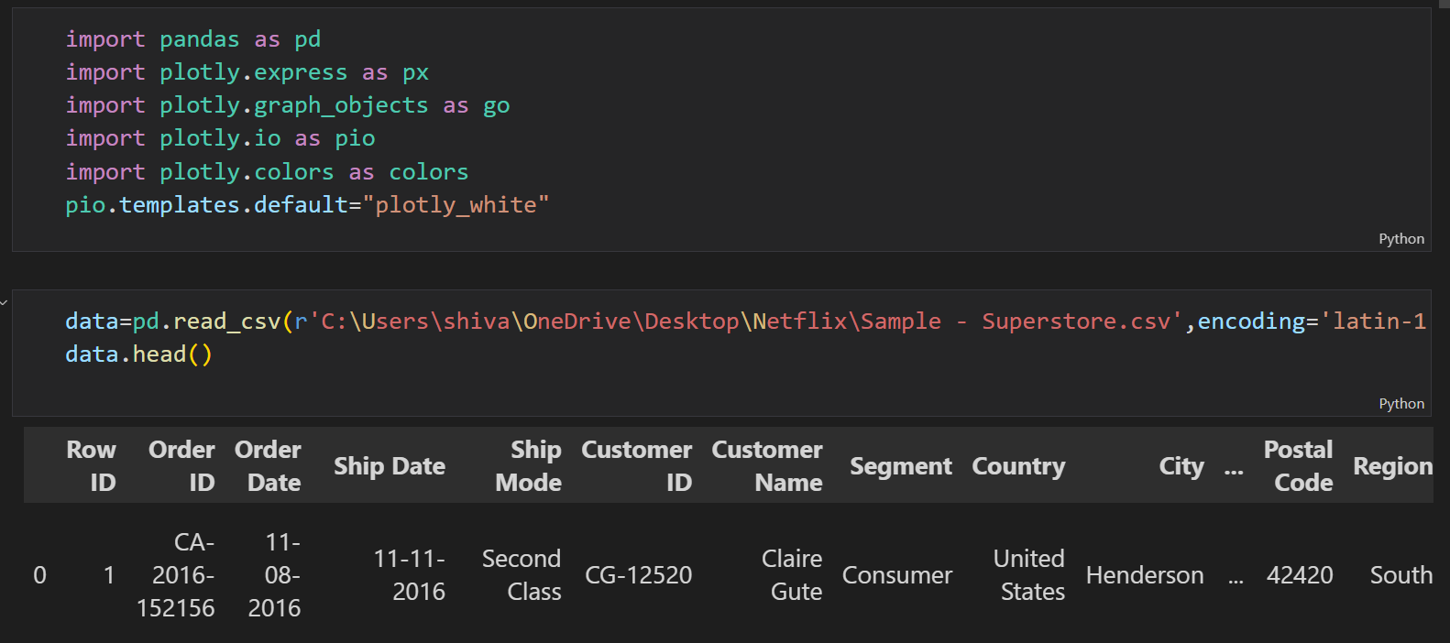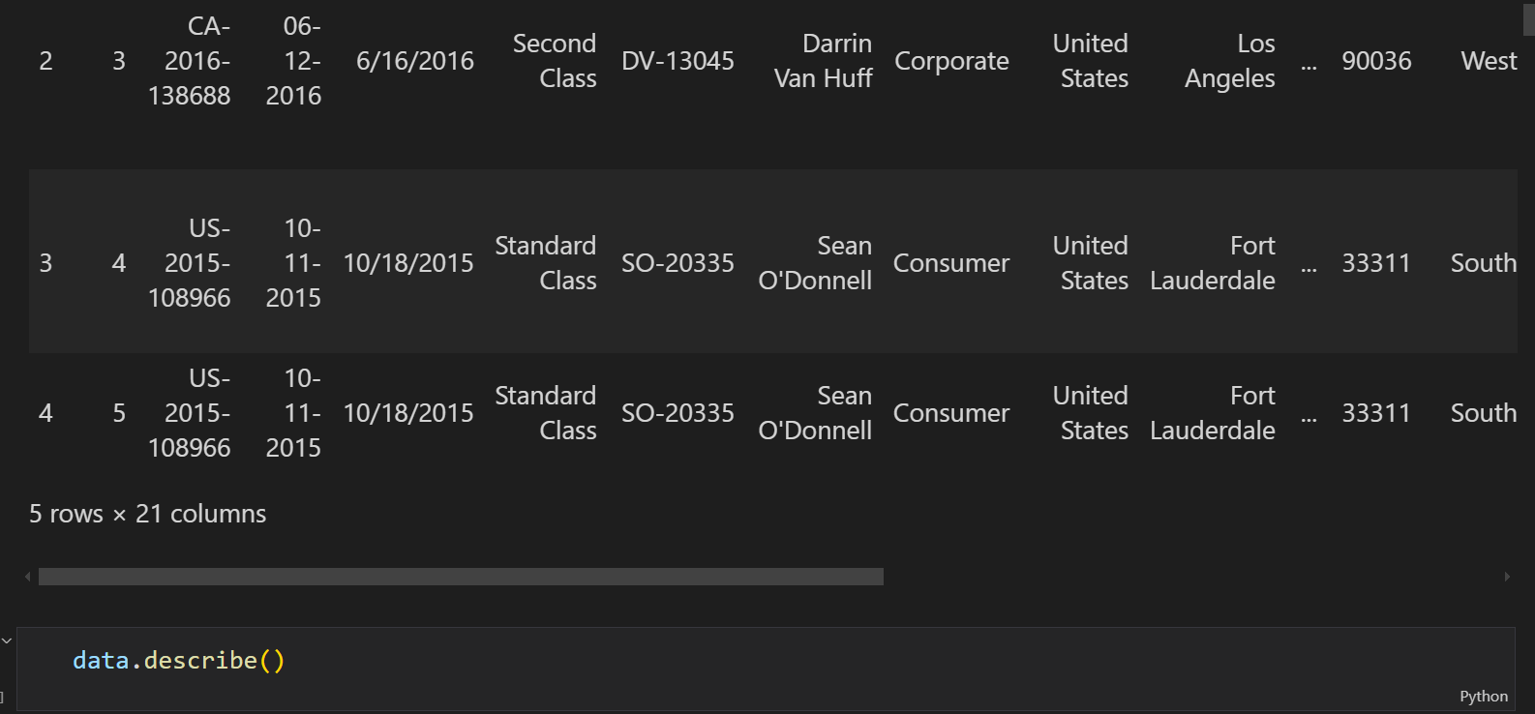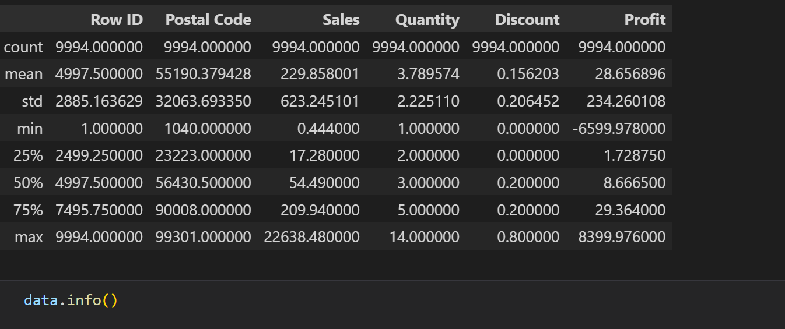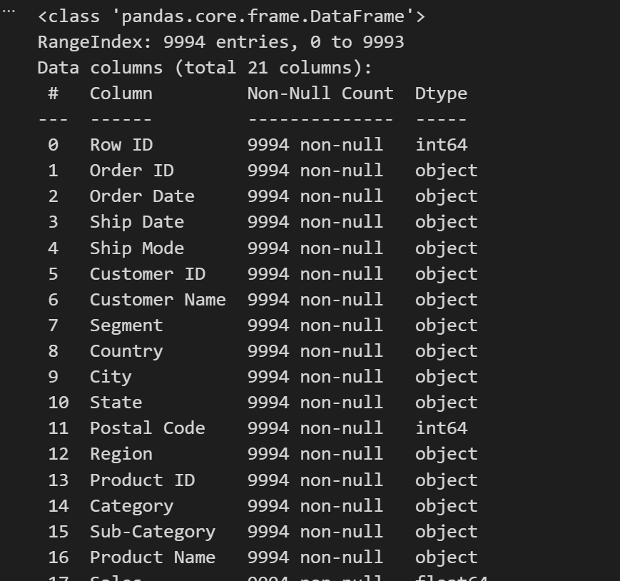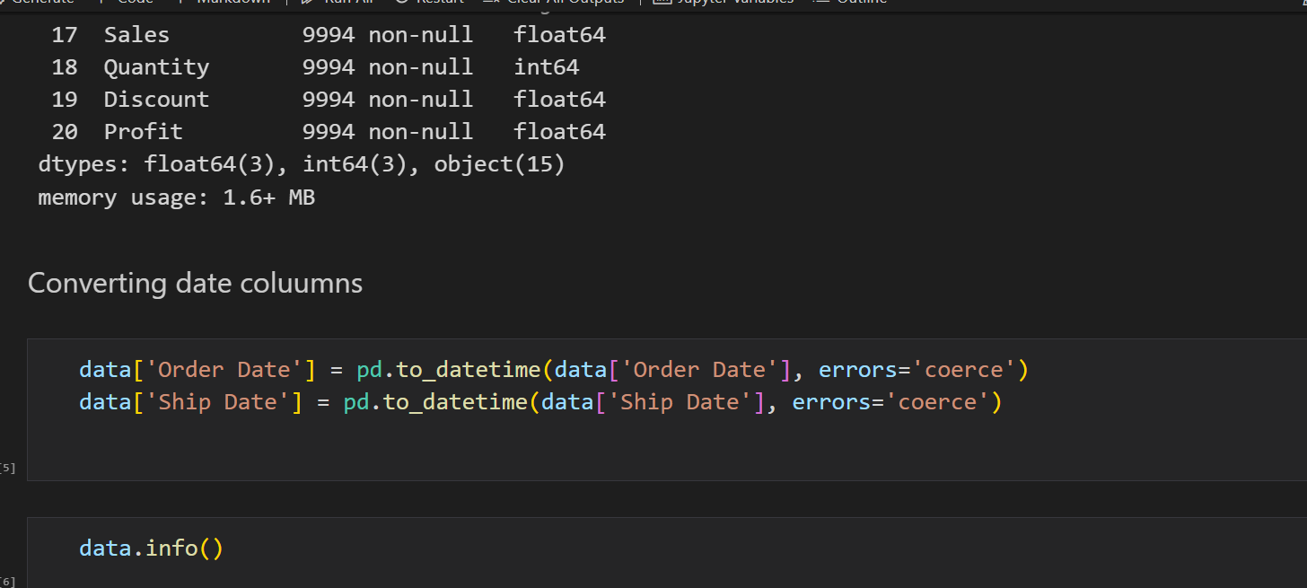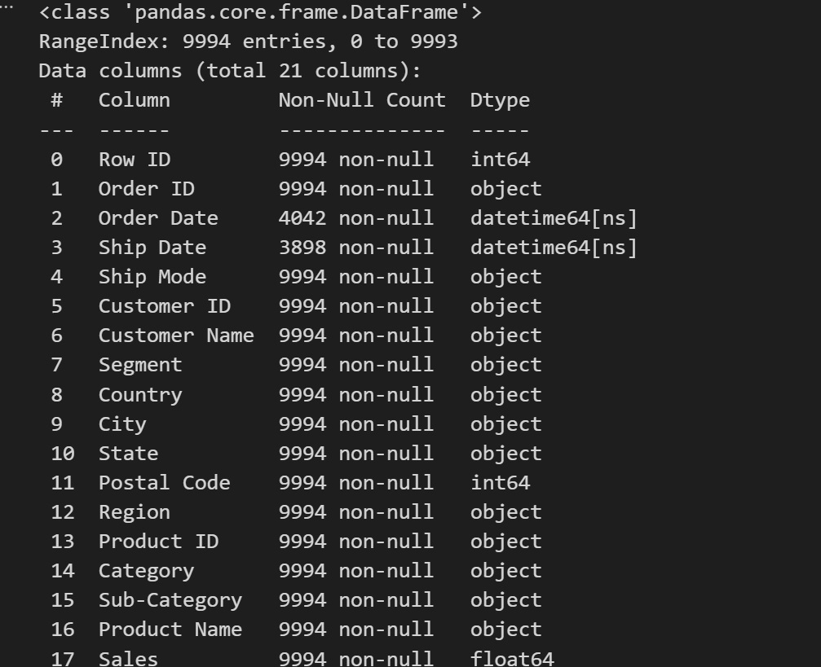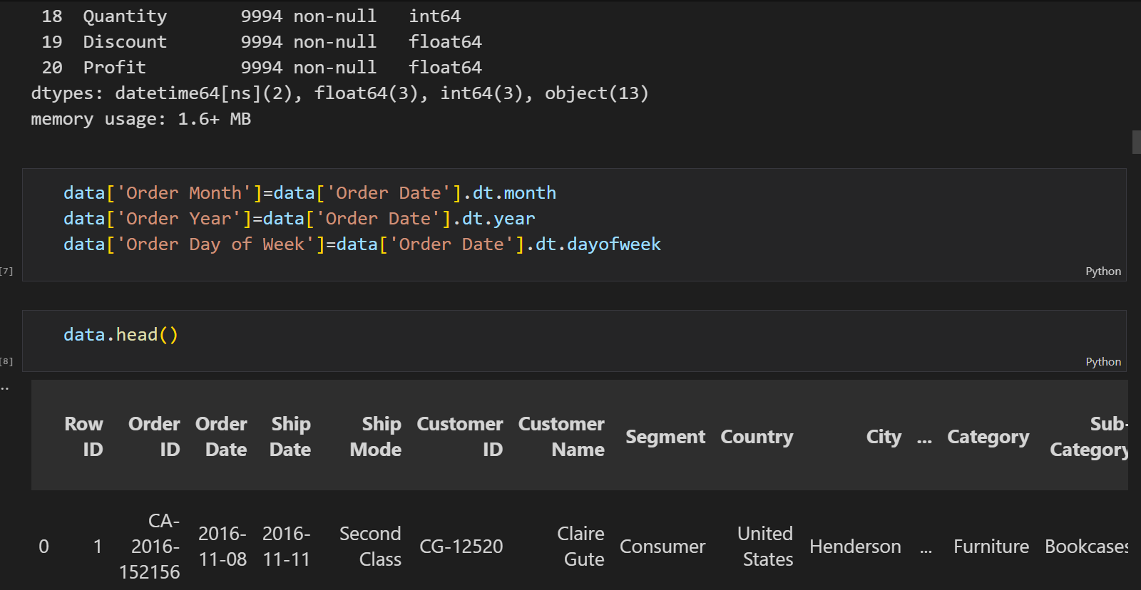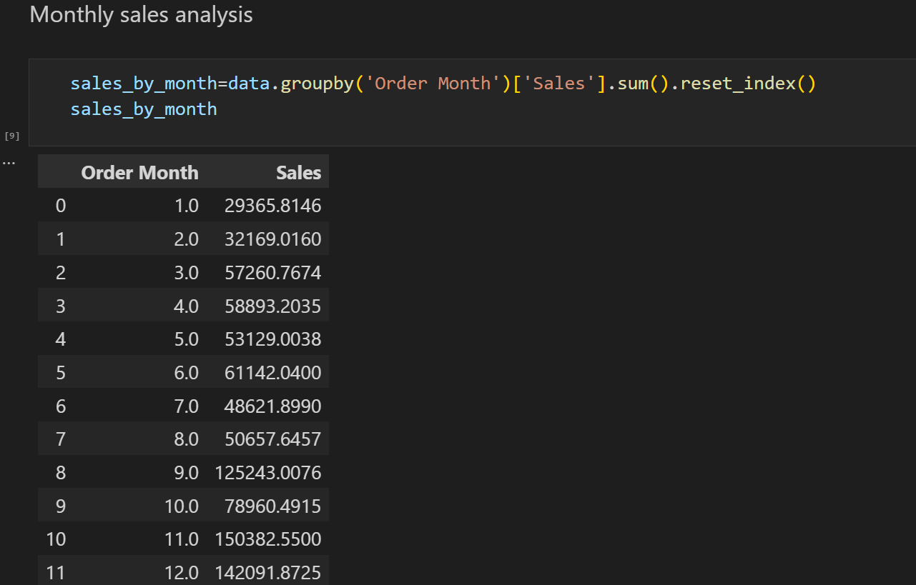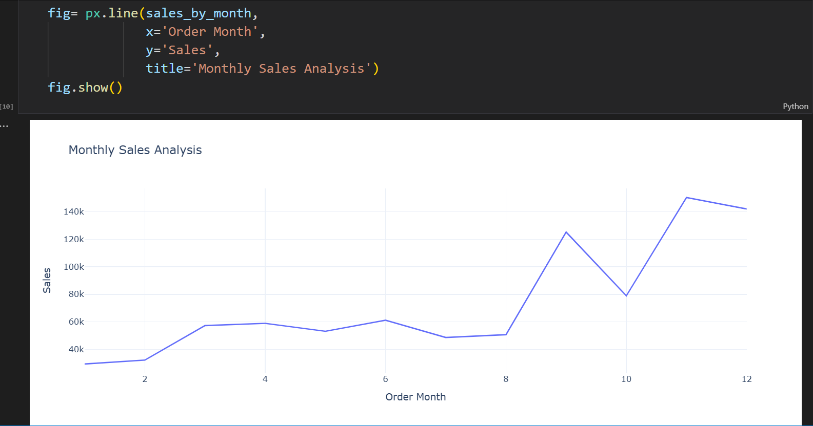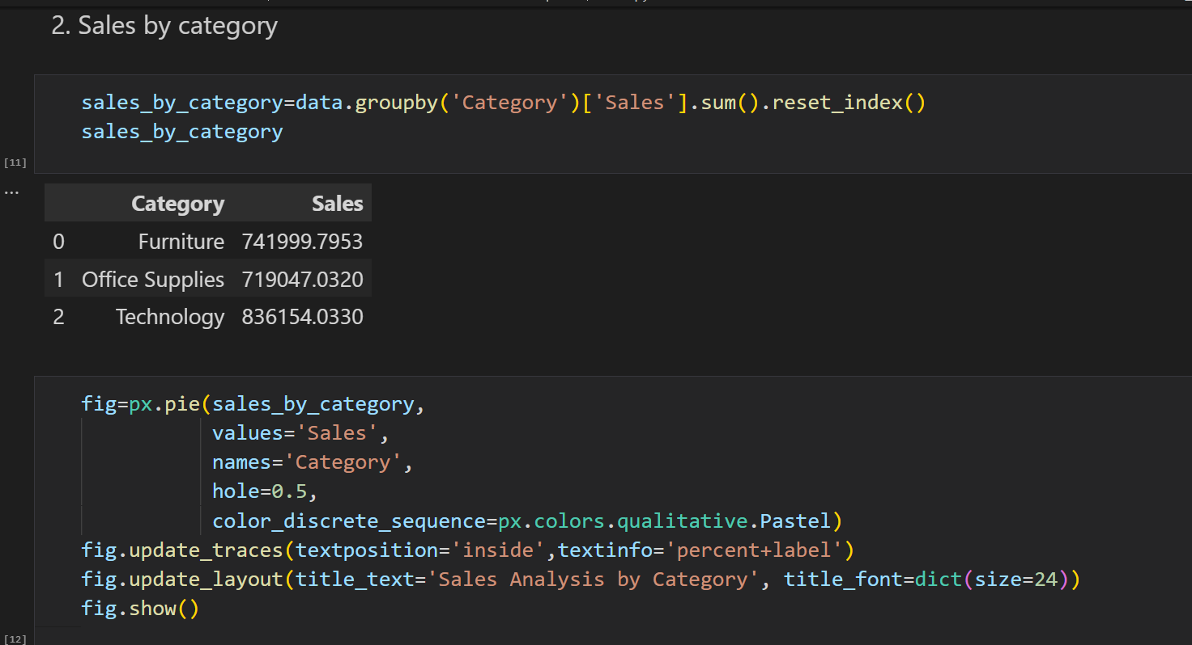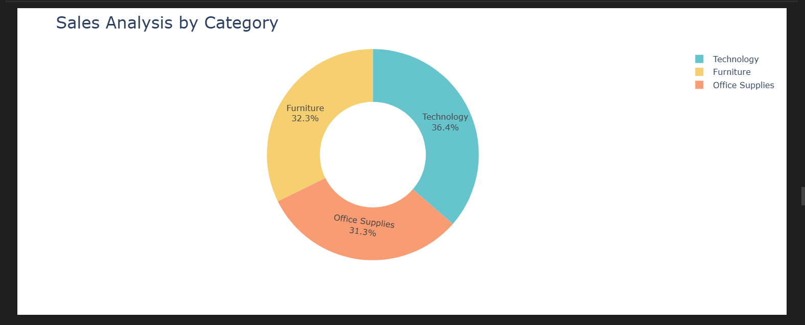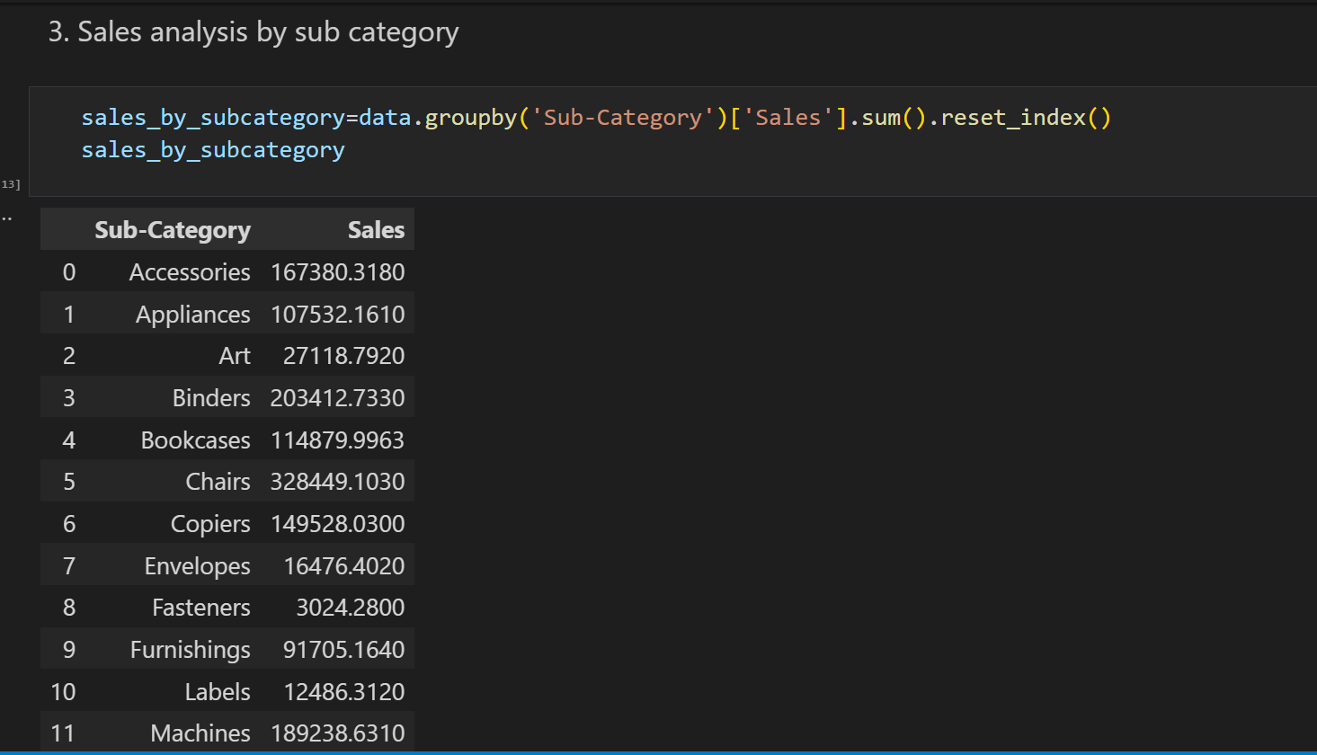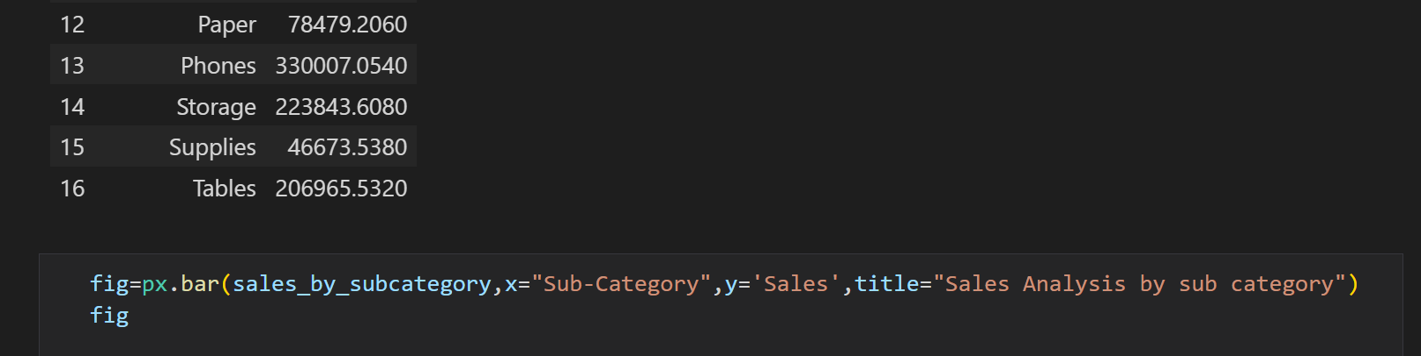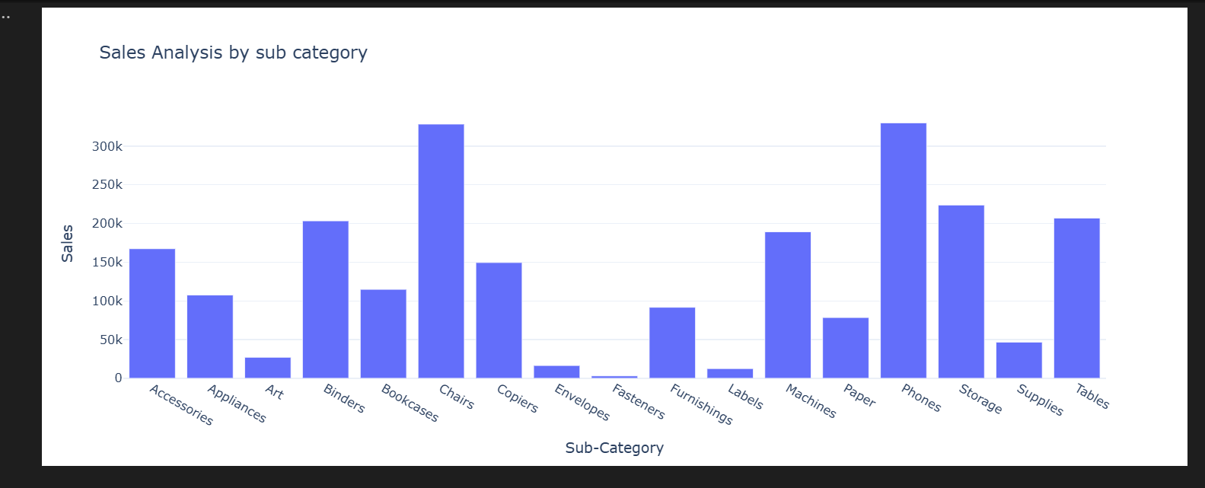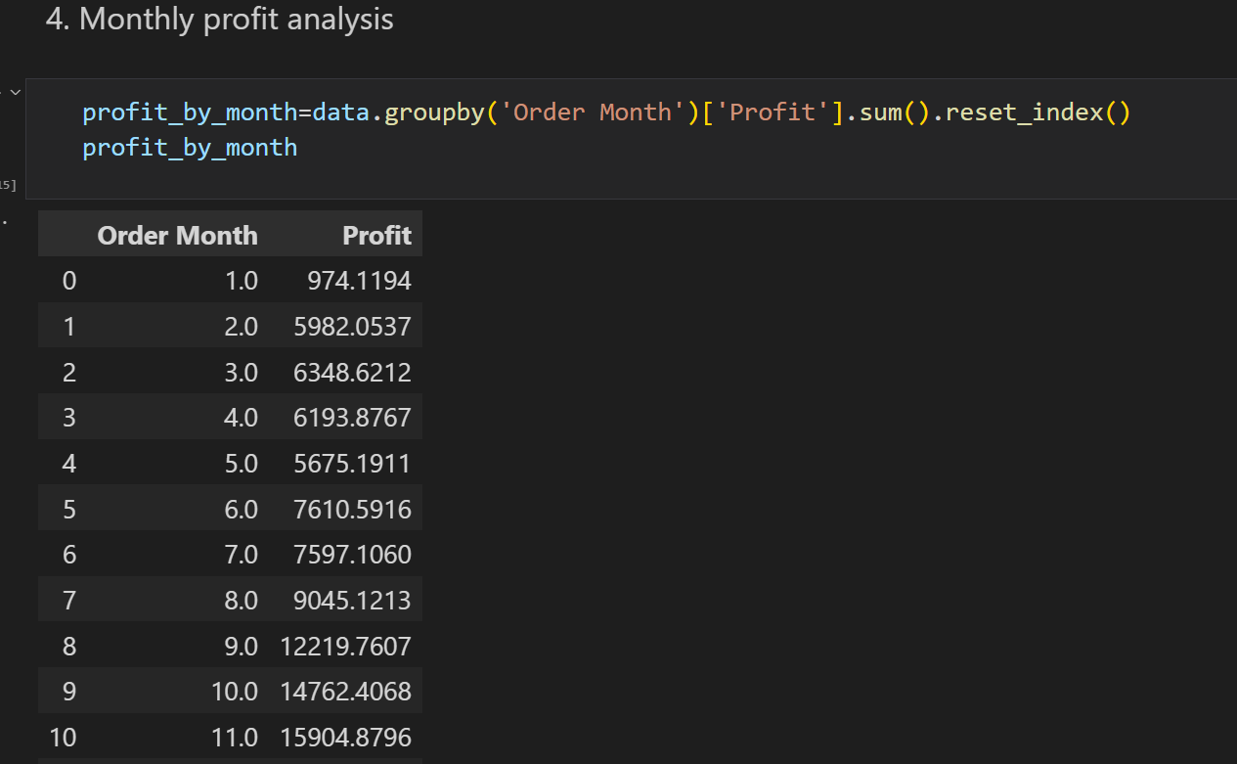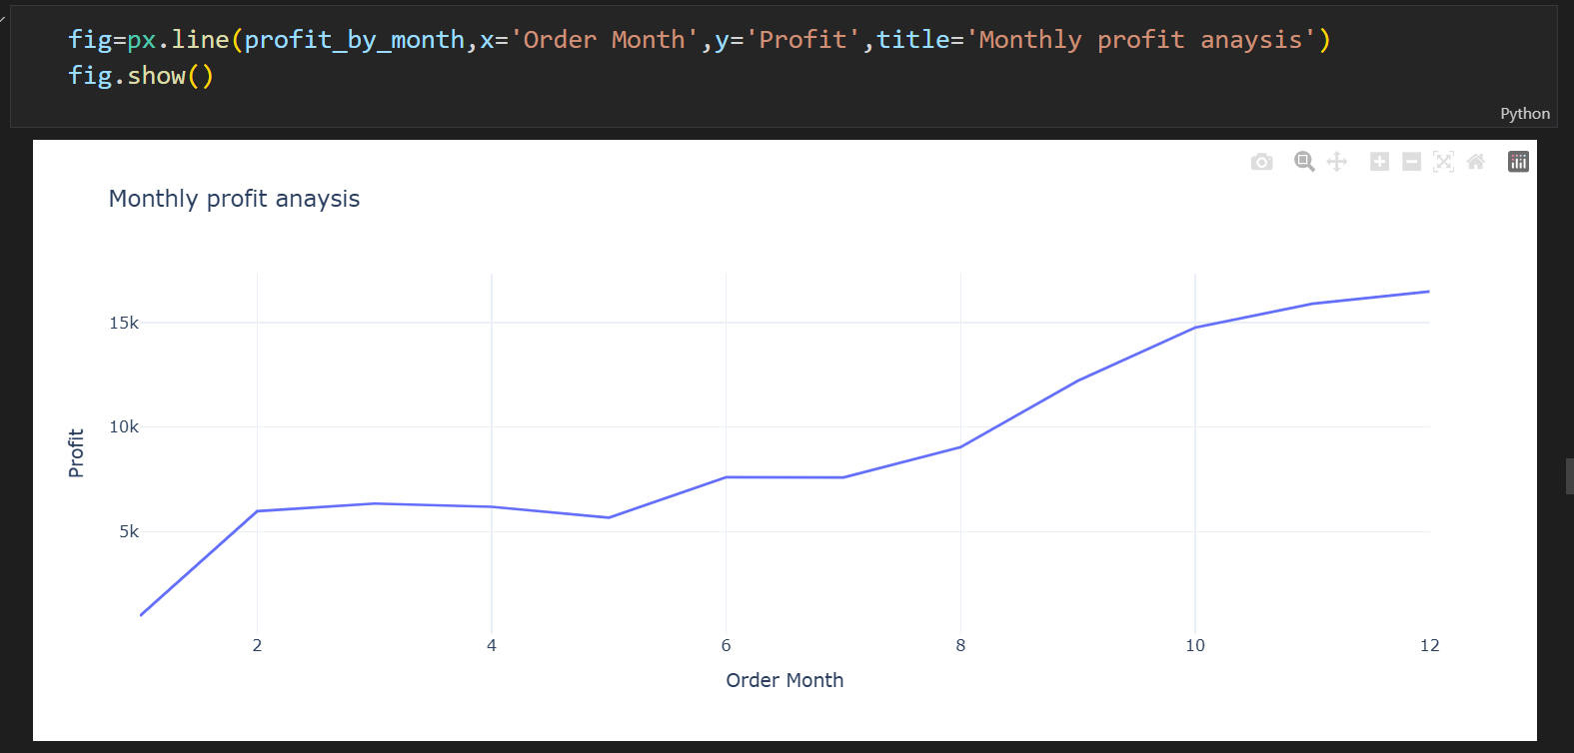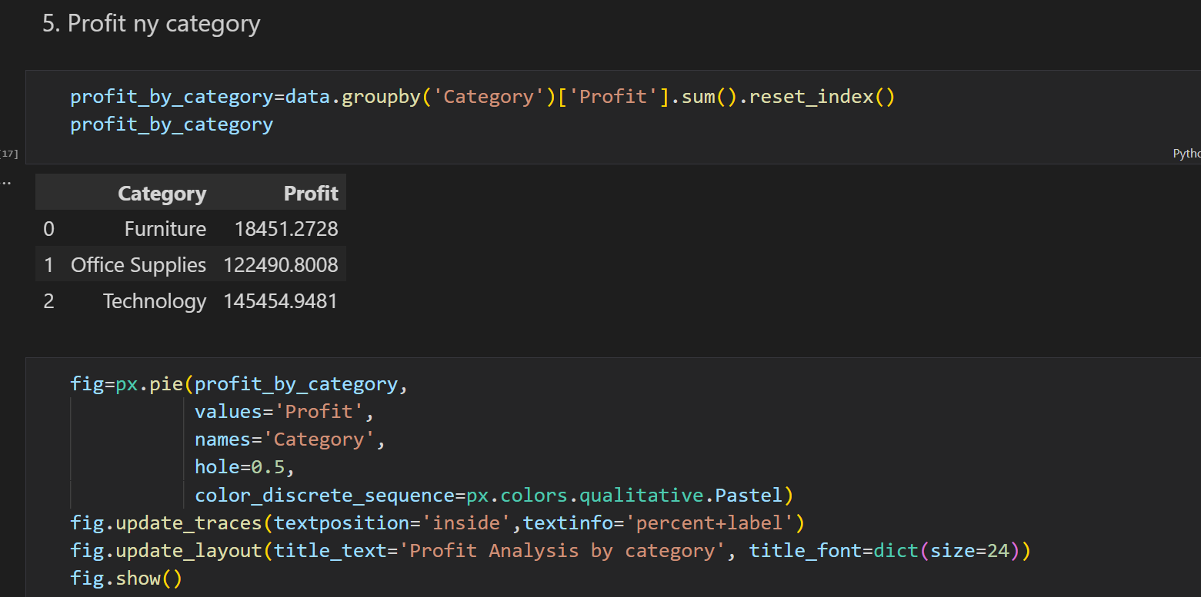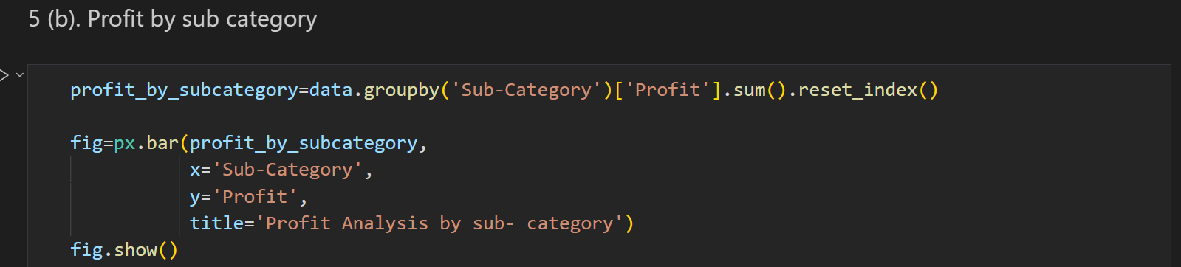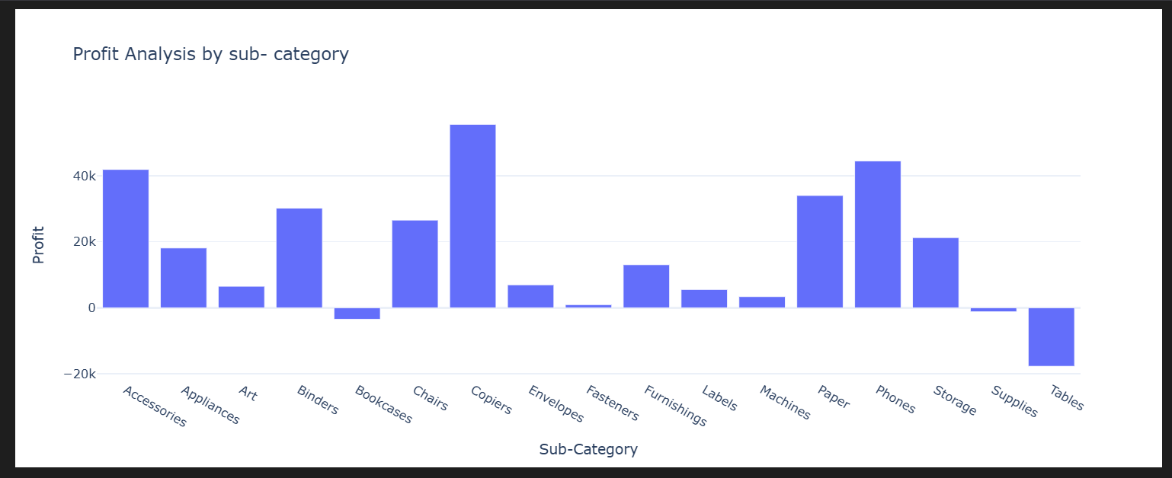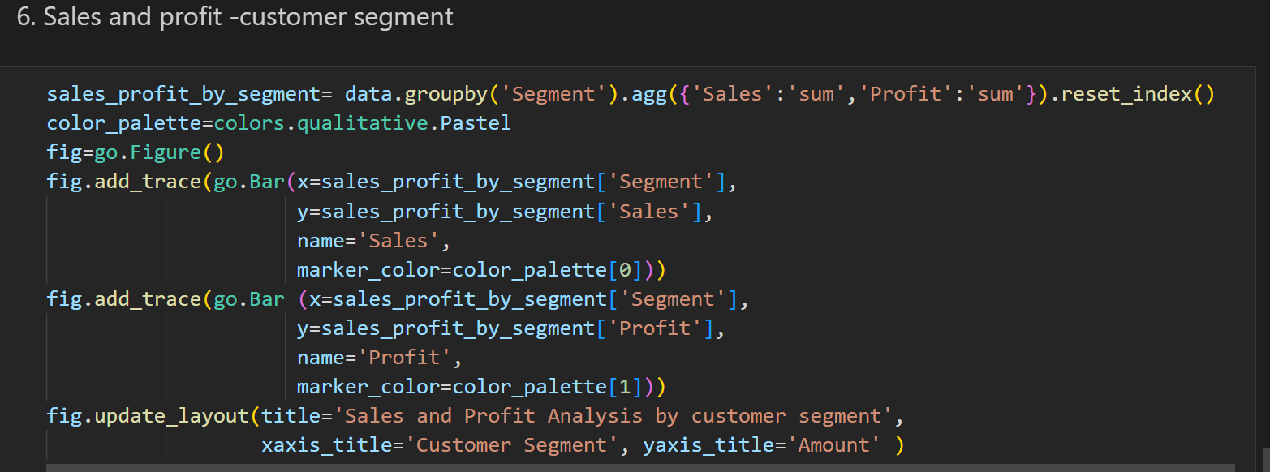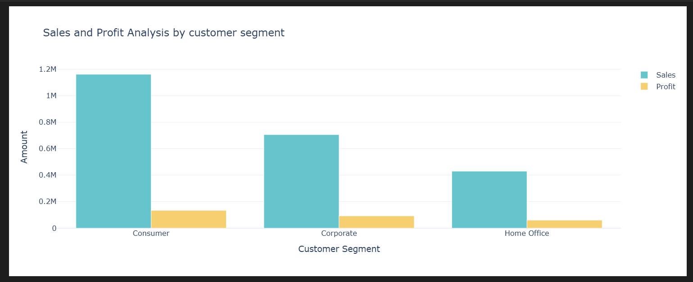 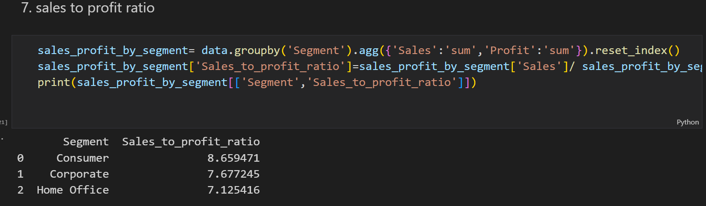

📄 **E-Commerce Sales Analysis – Project Summary**

**E-Commerce Sales Analysis | Python, Pandas, Matplotlib**  
Analysed 9K+ retail transactions to identify trends in sales, profit, region, and customer segments. Delivered actionable insights via charts and summary reports using Python libraries. Improved decision-making by highlighting low-performing categories and peak sales periods.